**Name & ID**:_________Basil khowaja__bk08432_______________ Date: 29/10/24

|  |
| --- |
| **EE-424L Data Communication & Networking**  **Fall 2024**  **Habib University**  **Dhanani School of Science & Engineering** |

LAB 8: **Static and Dynamic Routing Protocols**

|  |  |  |  |  |  |  |  |  |  |  |  |  |  |  |  |  |  |  |  |  |  |  |  |  |  |  |  |  |  |  |  |  |  |  |  |
| --- | --- | --- | --- | --- | --- | --- | --- | --- | --- | --- | --- | --- | --- | --- | --- | --- | --- | --- | --- | --- | --- | --- | --- | --- | --- | --- | --- | --- | --- | --- | --- | --- | --- | --- | --- |
| **Lab #8 Marks distribution:**   |  |  |  |  |  |  |  | | --- | --- | --- | --- | --- | --- | --- | |  |  | **LR2=20** | **LR4=10** | **LR5=40** | **LR9=10** | **AR4=20** | | **In-Lab Tasks** | **Task 1** | /5 |  | /10 | /10 | /20 | | **Task 2** | /5 | /10 | /10 | | **Task 3** | /5 |  | /10 | | **Task 4** | /5 |  | /10 |  |  | | **Marks Obt.** | **/100** | | | | | | |

|  |  |
| --- | --- |
| o**bjectives** | **The objective of this lab is to learn about Static and Dynamic Routing protocols and configure them on Routers.** |

|  |  |  |
| --- | --- | --- |
|  |  | |
|  | |  |

**Introduction:**

We saw in lab 6 how to connect two routers all you did was to assign IP address to the interfaces that are responsible for connecting two routers. But when more than two routers are involved things change. Directly connected routers only require IP address assignment at their specific interface (ports) but to learn the existence of routers that are not directly connected we need to specify their **Network Address** so the two routers that are beyond the reach can recognize each other.

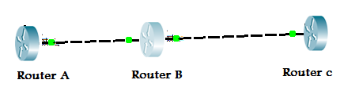

This concept should get clear by observing the above diagram where you can see that Router A and Router B are directly Connected and Router B and Router C are directly connected but Router A and Router C are not so for Router A to reach Router C it should have information of the Network that exist between Router B and Router C similarly for Router C to reach Router A it should have information of Network between Router A and Router B.

|  |  |  |
| --- | --- | --- |
| **Task 1:** | **[20]** | |
|  | |  |

Today’s task is to interconnect all the routers so that communication can happen between them for this purpose out of many options one is to create Staticx Route which we will explore in this Lab given below is the network along with the IP addresses to be assigned to each port. As it is quite obvious from the screen shot given below that there are **“four”** different Networks present **11.0.0.0**, **12.0.0.0**, **13.0.0.0** and **14.0.0.0** . **Configure below network topology on Router in Packet Tracer.**

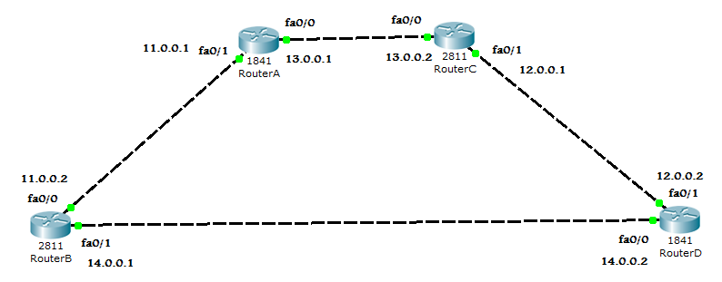

|  |  |  |
| --- | --- | --- |
| **Directly Connected Routers** | | |
| **Router A** | **Router B** |  |
| **Router A** | **Router C** |  |
| **Router B** | **Router D** |  |
| **Router C** | **Router D** |  |

Table 1: Showing Directly Connected Router Information

Above table shows that:

Router A is connected to Network _____11_______ and ___13______

Router B is connected to Network _____11______ and ____14_____

Router C is connected to Network _____13_______ and ____12_____

Router D is connected to Network _____12_______ and ____14_____

**ROUTER A**

Router>en \\use en or enable to go to privilege mode

Router#config t \\ use config t to move to configuration mode

Router(config)#interface fa0/0

Router(config-if)#ip address 13.0.0.1 255.0.0.0 \\assigning IP address to this port

Router(config-if)#no shut \\ bringing the port to UP state

Router(config-if)#exit

Router(config)#interface fa0/1

Router(config-if)#ip address 11.0.0.1 255.0.0.0

Router(config-if)#no shut

Router(config-if)# exit

Now comes the part of telling Router A about those Router Networks that are not directly Connected to Router A. This is done through specifying “STATIC ROUTES” shown below:

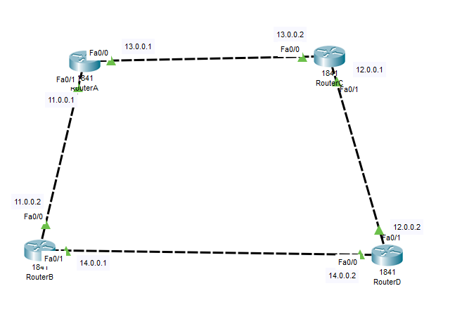

RouterA(config)#ip route 12.0.0.0 255.0.0.0 13.0.0.2

RouterA(config)#ip route 14.0.0.0 255.0.0.0 11.0.0.2

(destination, subnet mask, gateway)

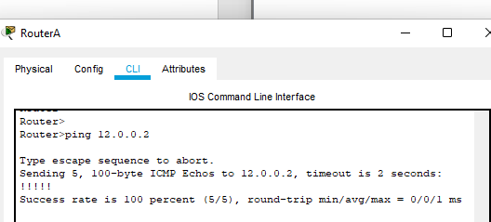

RouterB(config)#ip route 13.0.0.0 255.0.0.0 11.0.0.1

RouterB(config)#ip route 12.0.0.0 255.0.0.0 14.0.0.2

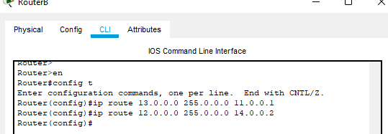

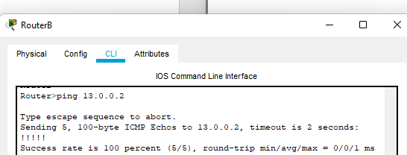

RouterC(config)#ip route 11.0.0.0 255.0.0.0 13.0.0.1

RouterC(config)#ip route 14.0.0.0 255.0.0.0 12.0.0.2

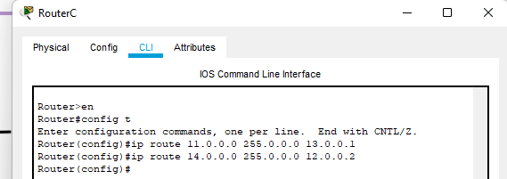

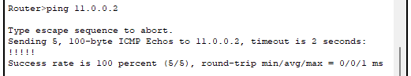

RouterD(config)#ip route 11.0.0.0 255.0.0.0 14.0.0.1

RouterD(config)#ip route 13.0.0.0 255.0.0.0 12.0.0.1

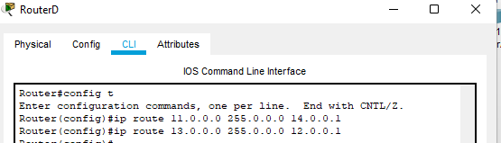

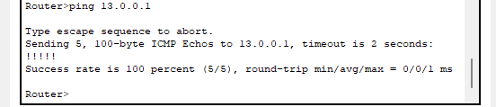

Here **ip route** is key word for specifying “Static Routes” after this key word mention the network address that is not directly connected to router then comes subnet mask after subnet mask is the address through which this router will access network 12.0.0.0 and in the end gateway for Router A i.e 13.0.0.2

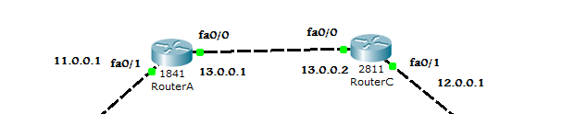

**Fig: Showing Router A’s gateway (13.0.0.2 at Router C) for network 12.0.0.0**

Similarly,

Router(config)#ip route 14.0.0.0 255.0.0.0 11.0.0.2

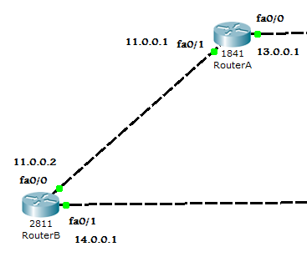

Router A use _11.0.0.2____ as gateway for network 14.0.0.0

Repeat the above steps for Router B, C and D. . **(Screenshots attached above)**

**Attach the screenshot of your Network topology and configuration of static routes in Router B, C and D.**

**View the Routing and ARP table by using Inspect Tool. Attach the screenshot and discuss the results.**

|  |  |
| --- | --- |
| **Task 2: Configure Static Routing** | **[25]** |

**Configure Static Routing on given below network topology. Use Automatic Connection cable to make connections between routers. Ignore red link (serial cable) established between routers.**

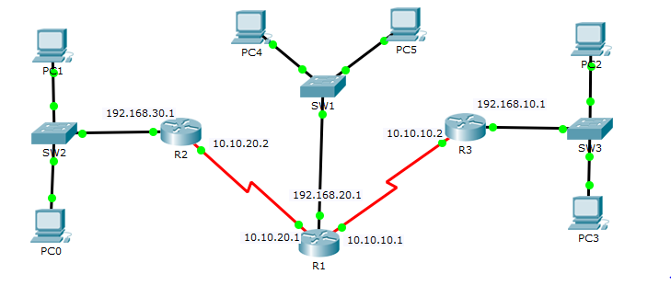

Fill the below table using information provided in above topology.

|  |  |  |
| --- | --- | --- |
|  | **Static Routes** | **Gateways for Static Routes** |
| **R1** | |  | | --- | |  |  |  | | --- | | 192.168.10.0,192.168.30.0 | | 10.10.10.2,10.10.20.2 |
| **R2** | 192.168.20.0,192.168.10.0,10.10.10.0 | 10.10.20.1 |
| **R3** | 192.168.20.0,10.10.20.0,192.168.30.0 | 10.10.10.1 |

**Attach the screenshot of your Network topology and configuration of static routes in Router 1,2 and 3.**

**Ping PC1 to PC5 and PC0 to PC2 and attach its Screenshot.**

**Discuss and attach the screenshot of Routing and ARP table for R1, R2 and R3.**

We did a similar thing in this task as we did in task 1(static routing). The thing that was different here was that even the shortest route between some of the routers had an additional router in between the path. Example when we had to connect router 3 and router 7 (naming convention according to the snippet I attached) we had to edit the command a little.

**Router3(config)#ip route 192.168.10.0 255.255.255.0 10.10.10.0**

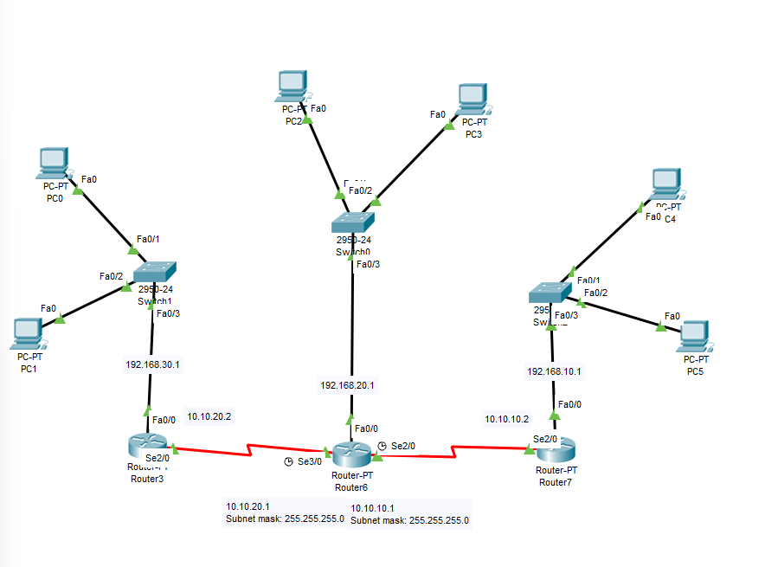



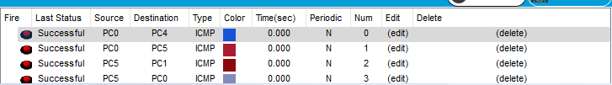



|  |  |
| --- | --- |
| **Task 3: Routing Information Protocol (RIP)** | **[10]** |

**RIP** (**R**outing **I**nformation **P**rotocol):

1. RIP is a Distance Vector Protocol
2. A Distance Vector Protocol is the one that select the best possible path by calculating the Distance and direction to its destination.
3. RIP uses the concept of “HOP COUNT”
4. HOP means “To Jump”. RIP calculates how many Networks (Routers) exist between source and destination.
5. Maximum Hop count of RIP is 15.
6. By default it sends updates after every 30 seconds
7. These updates are important to cater for new updates in the network.

**Configure Task 1 network topology using RIP protocol.**

**For Router A:**

Router(config)#interface fa0/0 \\ to configure fa0/0 port first access it

Router(config-if)#ip address 13.0.0.1 255.0.0.0 \\assigning IP address to this port

Router(config-if)#no shut \\ bringing the port to UP state

Router(config-if)#exit \\ exiting interface after configuration

Router(config)#interface fa0/1 \\ to configure fa0/1 port first access it

Router(config-if)#ip address 11.0.0.1 255.0.0.0 \\assigning IP address to this port

Router(config-if)#no shut \\ bringing the port to UP state

Router(config-if)# exit \\ exiting interface after configuration

Router(config)# router rip \\ **RIP** (**R**outing **I**nformation **P**rotocol)

Router(config)#network 13.0.0.0 \\ Assigning network

Router(config)#network 11.0.0.0 \\ Assigning network

**For router A:**



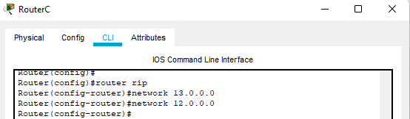

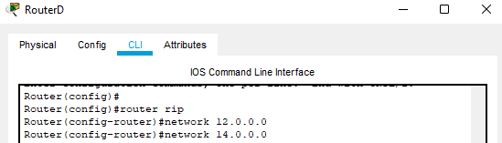

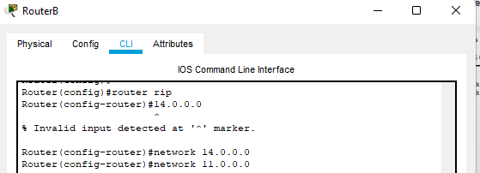

**For all Routers (just change only IP addresses & respective Networks in RIP). Attach screenshots of configuration for each Router.**

1. To verify which routing protocol is configured, use the **show ip protocols** command. Use the **debug ip rip** command to view the RIP messages being sent and received. Rip updates are sent every 30 seconds so you may have to wait for debug information to be displayed. Attach its screenshot below.

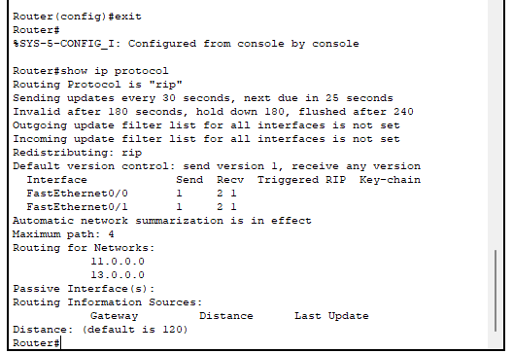

1. Discontinue the debug output with the **undebug all** command.



1. After the configuration, all the routers should be able to ping all the other routers. Check the routing table using show ip route command at each router and attach its screen shots.

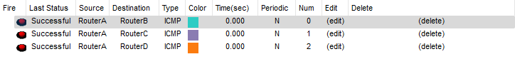All routers were able to ping each other successfully

|  |  |
| --- | --- |
| **Task 4:** | **[15]** |

**Configure RIP Routing on below network topology.**



**Attach the screen shots of Network model and configuration commands for RIP routing on R1, R2 and R3. Also, check the routing table on each Router and attach its screenshot.**

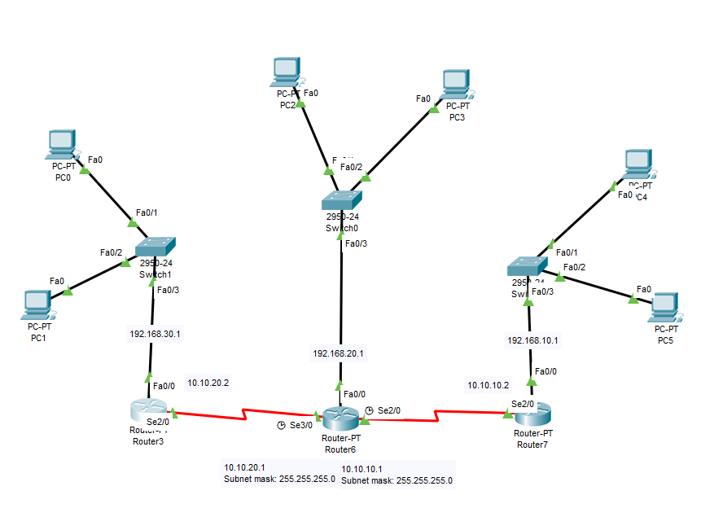

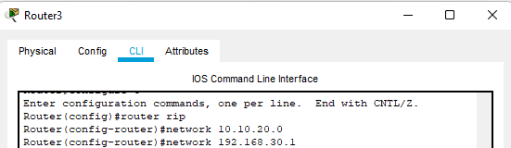

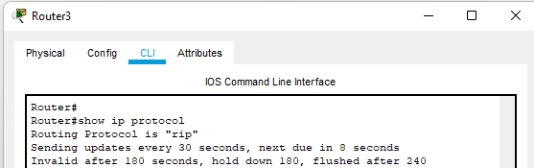

**(to show that rip protocol is indeed being used)**

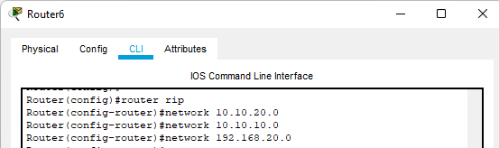

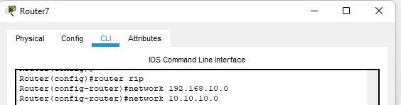

**Connectivity:**

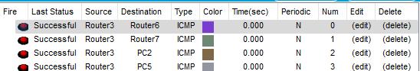

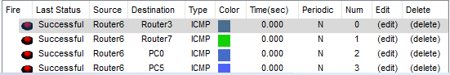

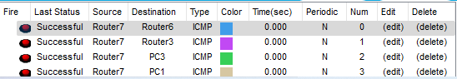

**Lab Evaluation Assessment Rubric**

**EE-424 Lab 8**

|  |  |  |  |  |  |
| --- | --- | --- | --- | --- | --- |
| **#** | **Assessment Elements** | **Level 1: Unsatisfactory**  **Points 0-1** | **Level 2: Developing**  **Points 2** | **Level 3: Good**  **Points 3** | **Level 4: Exemplary**  **Points 4** |
| **LR2** | **Program/Code/ Simulation Model/ Network Model** | Program/code/simulation model/network model does not implement the required functionality and has several errors. The student is not able to utilize even the basic tools of the software. | Program/code/simulation model/network model has some errors and does not produce completely accurate results. Student has limited command on the basic tools of the software. | Program/code/simulation model/network model gives correct output but not efficiently implemented or implemented by computationally complex routine. | Program/code/simulation /network model is efficiently implemented and gives correct output. Student has full command on the basic tools of the software. |
| **LR4** | **Data Collection** | Measurements are incomplete, inaccurate and imprecise. Observations are incomplete or not included. Symbols, units and significant figures are not included. | Measurements are somewhat inaccurate and imprecise. Observations are incomplete or vague. Major errors are there in using symbols, units and significant digits. | Measurements are mostly accurate. Observations are generally complete. Minor errors are present in using symbols, units and significant digits. | Measurements are both accurate and precise. Data collection is systematic. Observations are very thorough and include appropriate symbols, units and significant digits and task completed in due time. |
| **LR5** | **Results & Plots** | Figures/ graphs / tables are not developed or are poorly constructed with erroneous results. Titles, captions, units are not mentioned. Data is presented in an obscure manner. | Figures, graphs and tables are drawn but contain errors. Titles, captions, units are not accurate. Data presentation is not too clear. | All figures, graphs, tables are correctly drawn but contain minor errors or some of the details are missing. | Figures / graphs / tables are correctly drawn and appropriate titles/captions and proper units are mentioned. Data presentation is systematic. |
| **LR9** | **Report** | All the in-lab tasks are not included in report. | Most of the tasks are included in report but are not well explained. All the necessary figures / plots are not included. | Good summary of most of the in-lab tasks is included in report. The work is supported by figures and plots with explanations. | Detailed summary of the in-lab tasks is provided. All tasks are included and explained well. Data is presented clearly including all the necessary figures, plots and tables. |
| **AR4** | **\*Report Submission** | Late submission after 1 week and in between 2 weeks. | Late submission after 2 days and within a week. | Late submission after the lab timing and within 2 days of the due date. | Timely submission of the report and in the lab time. |

**\*Report:** Report will not be accepted after 1 week of due date